
University of the Arctic:
Thematic Network Social Work
Newsletter, December - 2012

Biannual Thematic Network Conference planned to be arranged 7- 8 July 2014 in relation to next “Social Work” world conference!

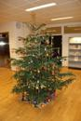  MERRY CHRISTMAS AND A HAPPY NEW YEAR!  DISCUSSION NOTE: “SUSTAINABILITY FOR OUR TNSW UARCTIC”  The steering committee for TNSWUA at our online meeting 12th of December, discussed how to make our network sustainable.  We think it is important that our home institution recognizes the importance of this network; to enhance collaboration regarding research, publications and education. Student & staff exchange in the Arctic - is important!  We ask all of you to discuss the possibility of implementing the following model:  Each participant in the steering committee asks to get 20 working hours for this work. This is a minimum and if people get more hours we will make this visible in the yearly report from our network regarding for example research collaboration.  We propose to divide work tasks in our network using these three categories: | a) Basic (Online steering committee meetings, coordinating function)  b) Additional; and needed (Newsletters)  c) Additional; and preferred (biannual conferences, research collaboration)  We are today 10 universities participating in the network (Finland and Norway are represented with two institutions). Each representative must use 8 hours for 4 online meetings. The one who is coordinator and the vice-coordinator should both use their additional 12 hours for organizing meetings, reporting, coordinating the work with the Newsletter, updating the webpage, contact with Arctic University etc.  Then we have 96 hours left to the rest of the work. 10 hours for producing one Newsletter (in total 40 hours), participating in the annual thematic meeting 12 hours (and this person representing the network may ask for additional time from his/her home institution), writing minutes from online meetings: 8 hours. Planning biannual conferences and publications: 36 hours.  Please email your opinion about this suggestion to: siv.oltedal@uin.no

Successful collaboration between VirCamp and Thematic Network:  A new online master course on: “Contextual Social Work” (30 ects) starting September 2013  The Thematic Network steering committee decided the 7th of December 2011 to establish a task force group. A similar decision was made at the VirCamp consortium management meeting the 15th of December 2011.  The Task force group with the following members: Lidia Kriulya, Russia, Petra Ahnlund, Sweden, Wim Wouters, Belgium/VirCamp and Siv Oltedal, Norway met in Bodø November 2012 for a two days working seminar.  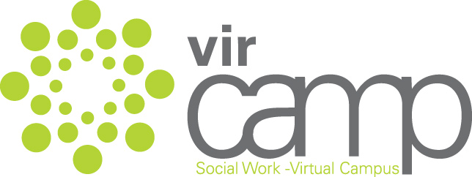  The Social Work Virtual Campus –VirCamp - www.vircamp.net - started as a Consortium in 2008 and aims to develop high quality online courses for social work students. The costs are covered by an institutional fee from each partner institution. Partners also contribute with teachers and assessors for the courses. Students from partner institutions are offered to join the courses.  Students from TNSWUA institutions can apply for Community Work courses (15 ects or 10 ects) to UiN. | The Thematic Network on Social Work was established the 15th of June 2006 at a conference at Kjerringøy, Norway. There are now network members from all eight arctic countries: Canada, USA, Island, Greenland, Russia, Finland, Sweden and Norway.  The “Contextual Social Work” - master course will be implemented at the University of Nordland and the University of Umeå from September 2013. Students who are interested to apply for the course must contact one of these universities.  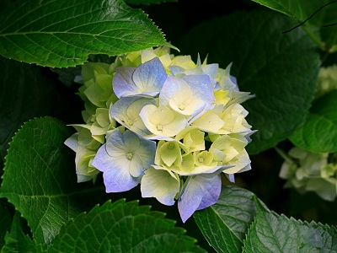  Members of the Steering Committee for TNSWUA:  Lidia Alexandrova Krulya NARFU, Arkhangelsk, Russia  Thorhildur Egilsdottir , University of Island, Reykjavik  Kaisu Vinkki, Kemi-Tornio Un. of Applied Sciences, Finland  Tarja Orjasniemi, University of Lapland, Finland  Eva Wikstrøm, University of Umeå, Sweden  Douglas Durst, University of Regina, Canada  Debbie Gonzales, Humboldt State University, USA.  Kåre Halvorsen, Soc.Ped.School, Greenland  Randi Haugland, Finnmark University College, Norway  Siv Oltedal, University of Nordland, Norway (coordinator)  About the newsletter:  This is a newsletter for “Thematic network on Social Work” within University of the Arctic.  Email: siv.oltedal@uin.no  Website: http://www.uarctic.org/singleArticle.aspx?m=281&amid=1143

Thematic focus on one Arctic University:
Indigenous Social Work at Finnmark University College – an integrated approach.

Edited by Associate Professor Randi Haugland, randi.haugland@hifm.no
Introduction: By Head of Department Nina Hermansen, nina.hermansen@hifm.no
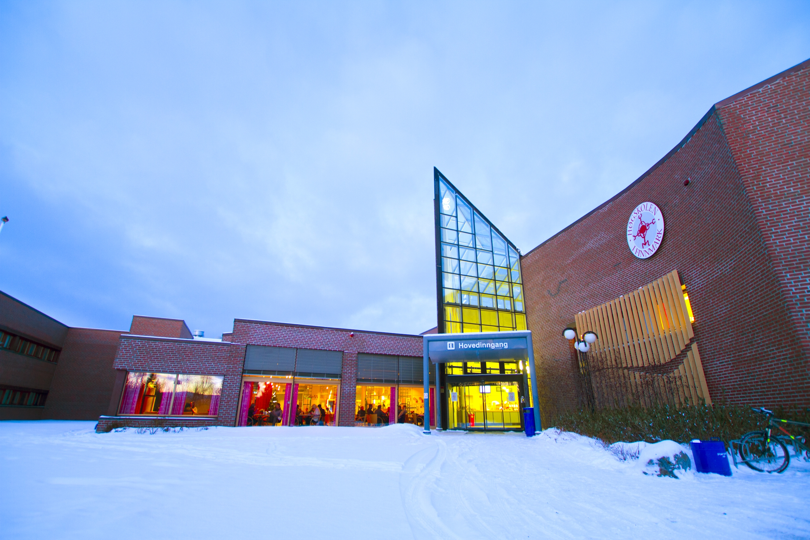 | Finnmark University College has approximately 1 800 students, spread over several campuses. The Department of Social Work and Child Welfare has approximately 400 students and offers a BA degree, as well as cross professional courses for further education.
Since the college is located in Norway’s northernmost county, in the heart of Sápmi, we have a special focus on issues related to the Northern regions with its indigenous people. We do not have separate Sámi, indigenous, aboriginal or rural programmes for social workers, like in Canada and the US, but integrate relevant theories into all relevant subjects by training the students in Cultural Analysis. This involves conceptual and professional skills with regard to diversity, especially in terms of gender, ethnicity, and social and economic inequality. To have acquired such qualifications in Cultural Analysis it is assumed that the student is knowledgeable about and can critically reflect on power relationships which social workers and users are involved in, is knowledgeable about approaches to cultural analysis in social work, and is able to apply this knowledge in real-life situations to promote mastery and development, and possesses knowledge and skills in cross-cultural communication, including the use of interpreters.
- In the following, we will present a few research projects in social work in a Sámi/indigenous context in the Arctic:

Development of Multicultural Perspectives: Associate Professor Jan Erik Henriksen, jan.henriksen@hifm.no is currently the project manager for an application to the Norwegian Research Council`s Strategic College Program. The project seek to examine how a Postcolonial Approach can support knowledge from both multiculturalism and indigenous philosophy, believing that this joint perspective can bring postcolonial discourses into Social Work Theory and Practice.

Coping with Violence – about young Sámi girls in Finnmark:Ass. Prof. Tordis K. Sovde, tordis.sovde1@hifm.no has together with Monica Bjerklund made a qualitative research project about how teenage Sámi girls experience different forms of violence in their daily lives. A key finding is that several of the informants cope with the violence by not talking about it, this being interpreted to be in accordance with traditional Sámi ways of coping with difficulties.

Child Welfare in Sápmi: Ass. Prof. Eli Synnøve Skum Hanssen, elish@hifm.no is looking at development of quality in Child Welfare Services for the Sami people through Intermunicipal Cooperation where Social workers can get guidance, supervision and support from each other in exploring children`s situation and establishing necessary support for the children and their families. The main finding is that professional networks can lift complex local issues into a bigger professional context, and are useful for good social work practice and for taking care of the Sami culture.

Building Social Capital in Indigenous Areas of Yakutsk through Family Work” : Associate Professor Eva Carlsdotter Schetne, eva.schjetne@hifm.no, has participated in an international development project from 2009 to 2012 in cooperation with North Eastern Federate University, Institute of Finance and Economics and Development Psychological Aid Centre, Yakutsk, Sakha republic, Russian Federation. They have worked on a Case study from the Sami core area of Finnmark. For the indigenous populations of the Barents region as well as in the other circumpolar nations, judgement about “best interests of the child” are made by institutions representing the hegemonic society and it’s cultural representations.
Sámi identity without the benefit of Sámi Language: Ass. Prof. Ann-Mari Andersen, Ann-Mari.Andersen@hifm.no has the following issue for her project: In what way does lack of competence in the Sámi language have significance for how Norwegian speaking Sámi in the core regions of Sápmi, where the majority population speaks sámi, are included or excluded in society? The research shows that people experience difficulties in being recognized as “true” Sámi when they lack the language. The very symbol of true “Sáminess” is linked to mastery of the Sámi language, and that this has importance for inclusion and exclusion.

November 2012: Randi Haugland, Norway visits Doug Durst at U Regina, Canada
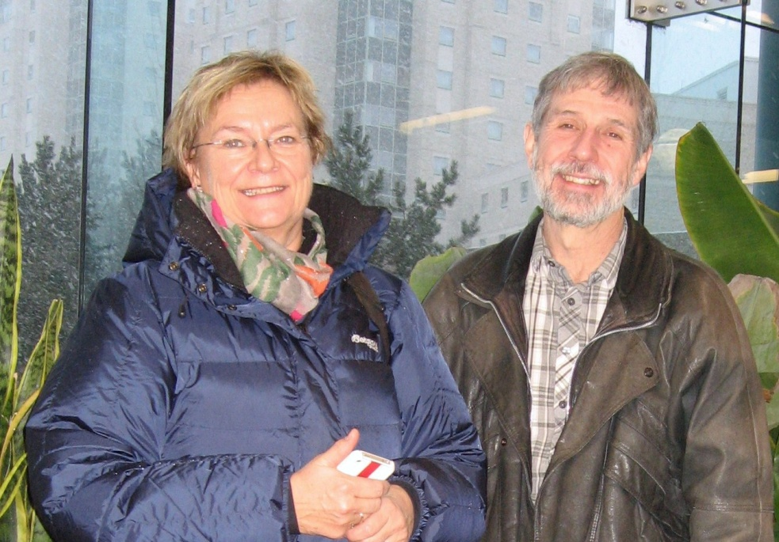  SIU (Norwegian Center for International Cooperation in Education and Research) wants to enhance student exchange in the Arctic. See also: www.studyinnorway.org. | Randi Haugland from Finnmark University College stayed at a conference in Montreal.  Without quite realizing how far away Regina is from Montreal, Randi planned for a trip to University of Regina, and was hosted by Doug Durst. He invited her to stay with him and his wife Joanna, and made a program for two working days consisting of a meeting with International Department of UR, a Roundtable Discussion about Reaching Sami People through higher Education, participation in a Rural Social Work Class and a meeting with Social Workers in Moose Jaw. The latter was with international students of Social Work from Vietnam and China.

