An Opportunity to Get Your Arctic Message Heard
at COP 15 in Copenhagen

This December the world gathers to determine the future of the planet with respect to climate change and its consequences. The UN climate conference COP15 is of critical importance to the Arctic. Governments from the Arctic and beyond must feel the full weight of public pressure to take urgent and decisive action.

WWF’s Arctic program will host a Big Tent in a central square in Copenhagen. The tent will host a range of programming – some permanent, some changing daily – focused on the Arctic, the impacts of the changing climate, and possible solutions. We want to open this opportunity up to Arctic-focused organizations. We believe who brings the message is less important than getting the message heard.
A mix of science and art, politics and culture will be used to raise awareness and build public pressure on the conference delegates to do the right thing.

The Program
The Big Tent will serve as a venue for a range of Arctic-related groups, for programming relevant to Arctic climate change.
Some examples of possible daily programming themes include:

- Indigenous Peoples
- Science
- Arctic Adventurers
- Business
- Youth
- Culture
- Films and Photographs
- Pole to Pole

As of July 2009 the program is still relatively flexible and open to collaborative opportunities. We hope to provide approximately one week of programming, with at least one event per day.

What We Can Provide
The Big Tent will be located in Nytorv Square in downtown Copenhagen. Alongside it will be an outdoor photo exhibit of stunning photographs showing the natural values at risk in the Arctic as a consequence of climate change.

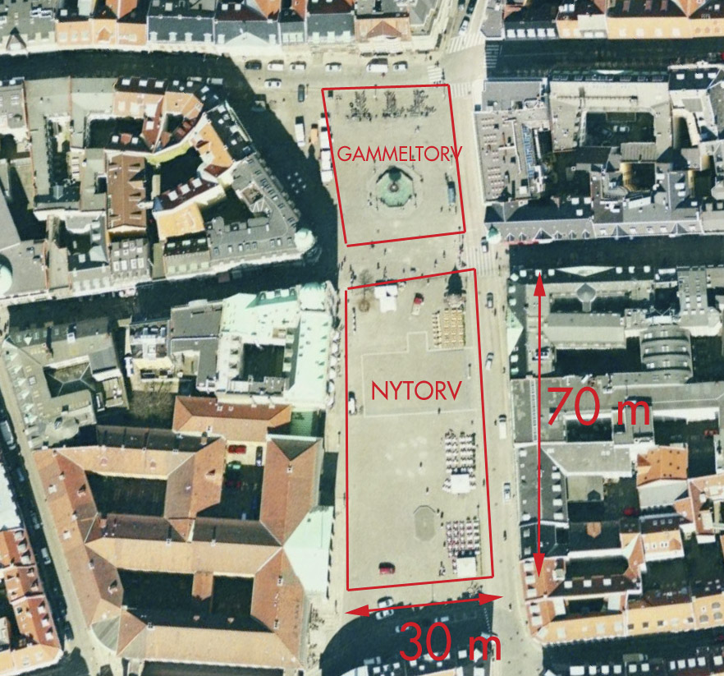

It is expected to seat ~150 people, or hold ~200 standing. It will be fully equipped with tables, chairs, a performance area, audio-visual apparatus, etc. Coffee and other refreshments will be available throughout the day. Arrangements with caterers will be possible to provide more substantial menus for events as required.
Security will be provided at night when the tent is not in active use.

The Audience
Conference delegates will be targeted indirectly through conditioning the public environment in Copenhagen so that the Arctic message becomes inescapable.
Promotion of the activities in the Big Tent will be co-leveraged by the efforts of the various organizations involved in the programming, creating a buzz among many different constituencies at the COP.
Linked to the Big Tent, a series of billboard advertisements across Copenhagen will broadcast the message of urgent Arctic climate signals.
Media will also be invited to specific events. We will provide stories from an Arctic perspective, posting our program in the media room, and conducting active outreach with key international media. A work area will be set up for journalists, complete with internet access to allow them to file stories direct from the tent.
Much of the content from the Big Tent will be packaged for web use. A daily blog will feature photographs and video of the key speakers. Material packaged at the end of each day can be used as a video media release for reporters the next day, delivered to their work area at the COP. We are also exploring the possibility of web-casting events.

Opportunity to Collaborate
Please contact Clive Tesar ( CTesar@wwf.no ) for more information if you are interested in using the opportunity provided by the Big Tent to host an event or run a day of programming.

