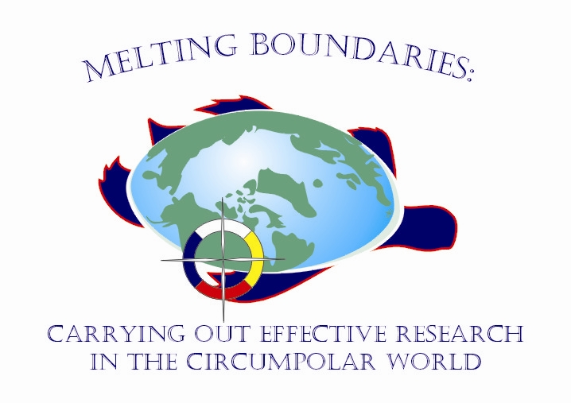
8th International ACUNS Student Conference on Northern Studies
University of Saskatchewan
Saskatoon, Saskatchewan
October 18-21, 2007

Invitation for northern students to participate in student round table discussion

The ACUNS Student Conference on Northern Studies is Canada’s premier conference on northern research, and will be held in Saskatoon, Saskatchewan, October 18-21, 2007. The theme of the conference is Melting Boundaries: Carrying Out Effective Research in the Circumpolar World. The intent of this conference is to showcase student research that has a northern scope with a special emphasis on interdisciplinary research and northern public policy. The primary mandate of this conference is to provide students with effective ways to facilitate and communicate research objectives between the scientific community and northern residents. The conference will be a platform for students to share their work and ideas, and broaden their understanding of northern issues. It is anticipated that this conference will serve as an outstanding opportunity for approximately 200 young academics from across Canada and other circumpolar countries (including Finland, Russia, Norway, and United States) to develop a community of Northern scholars. In so doing, it is hoped that this will help to broaden the scope of and interest in Northern studies and issues pertaining to the circumpolar region.

A special session, dedicated to northern students and northern research policy, has been incorporated into the conference. The northern students will be asked to discuss the following questions:
What are the obligations of northern researchers to the land and the people of the north?
Are these obligations currently being fulfilled?
What should be done to improve the fulfillment of these obligations?
The structure of this session will be a round-table discussion, lead by Karla Williamson from Inuit Tapiriit Kanatami (ITK), and her daughter, Laakkuluk Williamson from Nunavut Tunngavik Inc. The format of this session will be more interactive and hopefully a less intimidating approach to encourage students to participate and share their thoughts and ideas. We will share the information learned in the round-table discussion by writing a formal letter to the Minister of Indian Affairs and Northern Development detailing the issues and concerns that arise from this discussion. The session will be recorded onto digital format and converted into text. The dialogue of this discussion will be made available to the session participants. Our goal is to have 8-10 northern students, representing all three territories, participating in this session. This session has been sponsored by the Walter and Duncan Gordon Foundation. Travel and accommodation will be provided for all students participating in this session.

We are currently seeking nomination of eligible students to participant in this session. Please contact Alexis Schafer (alexis.schafer@usask.ca) to nominate a northern student.

