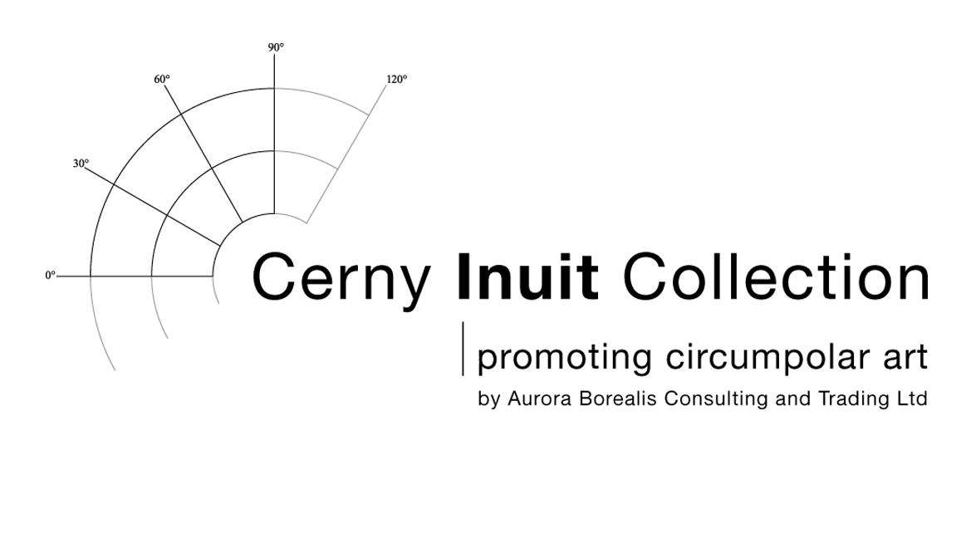
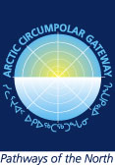

PRESS RELEASE

Date for Release: Immediately

Exhibition and Round Table Official Launch to International Polar Year
Geneva, Switzerland

The Circumpolar Arctic is one of the least technologically connected regions in the world. In an effort to change that, the people who call this vast geographic area home have been stepping up to take their rightful place in the growing global information society. Over the past two decades, rapid changes to communication technologies have created a steady rise of organizations and leaders dedicated to finding ways to better promote and share aboriginal experiences, current events, traditional stories and art from all high Arctic regions.

Two events, the “Shared Arctic: Contemporary Circumpolar Artwork Exhibition” and a Round Table Discussion entitled “Breaking the Ice: Communications with the Arctic” have been scheduled in Geneva, Switzerland to celebrate both the depth of Arctic culture and the need to communicate common goals and challenges facing northerners. These two events will mark the official beginning of International Polar Year, 2007.

Under the high patronage of the United Nations Office at Geneva and with the endorsement of the Permanent Mission of Canada to the United Nations Office at Geneva, the exhibition will showcase a startling array of traditional and contemporary artwork by artists from across the Circumpolar Arctic. The Round Table will bring a diverse group of professional communicators, government and indigenous leaders together to discuss effective ways to connect Circumpolar Arctic communities to each other and the rest of the world.

"The public is being invited to learn more about the Circumpolar Arctic by exploring the exhibition celebrating original artworks by artists from the different Arctic regions. It is also a unique opportunity to bring Arctic region representatives together to explore common challenges and find ways to overcome them with new technologies," said Arctic Circumpolar Gateway Managing Director, Mary Stapleton.

Topics to be discussed include International Polar Year; First Arts; Circumpolar Connections - the Arctic from a Northern Cultural Perspective; Communication for Development; and Control of Intellectual Property - the Indigenous Point of View.

Presenters include professional communicators, gallery and museum personnel, government officials and indigenous people representing the circumpolar Arctic countries. Together they will explore the role of northern arts in intercultural communication, and the importance of information and communication technology (ICT) in Arctic cultural development.

The Cerny Inuit Collection, based in Switzerland; and the Arctic Circumpolar Gateway, based in Canada, see the exhibition and Round Table as an opportunity to introduce examples of the beautiful artworks produced in the circumpolar North, as well as a means of deepening mutual understanding of the context in which they are created.

For more information or to pre-register contact:
Martha Cerny Mary Stapleton
Cerny Inuit Collection Arctic Circumpolar Gateway
Gerechtigkeitsgasse 50/52 Box 12, Site 7, R.R. 8
3011 Bern, Switzerland Calgary, Canada T2J 2T9
tel. + 4131 318 2820 tel. +1 403 931 2453
fax +4131 318 2821 fax +1 403 931 2454
cerny.inuit@bluewin.ch mary@stapleton.ca

