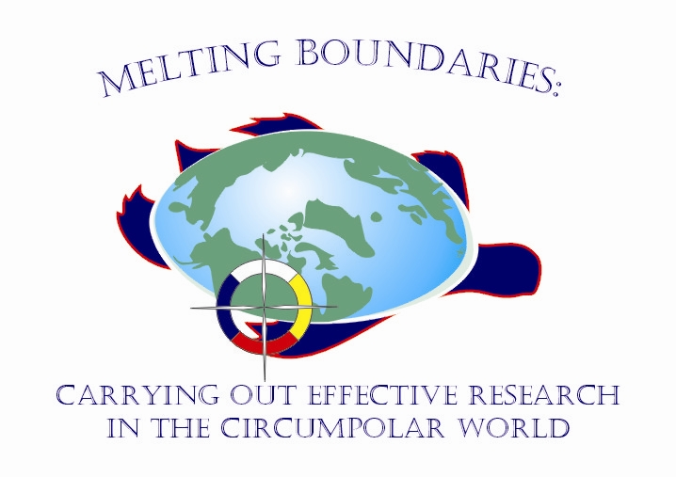

8th International Association of Canadian Universities for Northern Studies (ACUNS) Student Conference on Northern Studies
University of Saskatchewan, Saskatoon, Saskatchewan
October 19-21, 2007

Second Call for Abstracts

The 8th International ACUNS Student Conference on Northern Studies, titled Melting Boundaries: Carrying Out Effective Research in the Circumpolar World will be held in Saskatoon, Saskatchewan, Canada on October 19-21, 2007. We are expecting participants from around the circumpolar world, including Canada, United States, Finland, Norway, Russia, and other countries. Additionally, an International Polar Year (IPY) themed workshop will be held on Thursday October 18, 2007 to provide an opportunity for students to interact with leading Arctic and Antarctic researchers.

The intent of this conference is to showcase student research that has a northern scope with a special emphasis on interdisciplinary research. The primary mandate of this conference is to provide students with effective ways to facilitate and communicate research objectives between the scientific community and northern residents. Our commitment is to recognize, respect and promote the diversity and wealth of worldviews of all persons involved in northern research. Our vision is for a spirit of openness, respect, sharing that will leave you with new inspiration and ways of thinking about northern research.

Suggested topics for student platforms and posters include, but are not limited to:

- Alternative Energy | - Aquatic Research
- Climate Change and Meteorology | - Cultural Reclamation and Protection
- Economics | - Environmental Contaminants
- Ethics and Research in the North | - Individual, Community and Population Health
- Public Policy | - Research Partnerships and Collaborations
- Traditional Indigenous Knowledge / Language | - Glaciology
- Flora, Fauna, and Avian Research | - Intellectual Property Rights
- Land Claims | - Social Justice

Platform presentations are limited to 30 minutes, with 20-25 minutes per platform followed by 5-10 minutes for questions and discussion. Poster presentations will be organized into a 90 minutes session, during which the author(s) must be available for questions and discussion. Students presenting research on public policy may submit a paper for consideration for the SIPP Best Student Paper on Public Policy Research, sponsored by the Saskatchewan Institute for Public Policy Research. Additional instructions for posters are available on the conference web page.

Abstracts can be submitted online at http://acuns2007.onware.ca. Please limit the abstracts to 200 - 400 words. Also, please include all authors’ names and contact information. The Department of Indian Affairs and Northern Development (DIAND) has generously provided funds to offset the cost of travel for Canadian students to Saskatoon for participation in the conference. Details regarding registration costs and how the DIAND funds will be distributed will become available at http://acuns2007.onware.ca in the near future

Deadline for submission of abstract has been extended to May 15, 2007
Notification of acceptance will be delivered by May 30th, 2007
Submission of manuscript by September 30th, 2007 (for SIPP Best Student Paper Award)

If you have any further questions, please don’t hesitate to contact Brian Laird via email (brian.laird@usask.ca) or via phone (306-966-4299).

