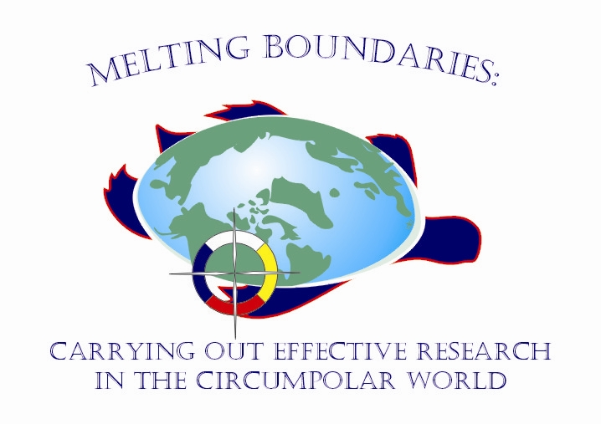

8th Association of Canadian Universities for Northern Studies (ACUNS) International Student Conference on Northern Studies
Melting Boundaries: Carrying Out Effective Research in the Circumpolar World

First Call for Abstracts

October 19-21, 2007
University of Saskatchewan, Saskatoon, Saskatchewan, Canada

Melting Boundaries: Carrying Out Effective Research in the Circumpolar World is 8th ACUNS International Student Conference on Northern Studies. The ACUNS student conference takes place every three years. This conference will be held in Saskatoon, Saskatchewan, Canada on October 19-21, 2007. We are expecting participants from around the circumpolar world, including Canada, United States, Finland, Norway, Russia, and other countries.

The intent of this conference will be to showcase student research that has a Northern scope, with special emphasis on interdisciplinary research. The primary mandate of this conference is to provide students with effective ways to facilitate and communicate research objectives between the scientific community and northern residents. Our commitment is to recognize, respect and promote the diversity and wealth of worldviews of all persons involved in northern research. Our vision is for a spirit of openness, respect, sharing and networking during the 2007 ACUNS student conference. Our hope is that you will leave with new inspirations and new ways of thinking about northern research.

Abstracts of paper and poster presentations can be submitted related to one of the following topics.

- Alternative Energy | - Aquatic Research
- Climate Change and Meteorology | - Cultural Reclamation and Protection
- Economics | - Environmental Contaminants
- Ethics and Research in the North | - Individual, Community and Population Health
- Public Policy | - Research Partnerships and Collaborations
- Traditional Indigenous Knowledge / Language | - Glaciology
- Flora, Fauna, and Avian Research | - Intellectual Property Rights
- Land Claims | - Social Justice

Research presentations will be in a variety of forms – before an audience, poster display, artwork or other medium. A paper presentation is limited to 30 minutes, with 20-25 minutes followed by 5-10 minutes for questions and discussion. Times will be strictly enforced. Poster presentations will be organized in 90 minutes session, during which the authors(s) must be available for questions and discussion. Instructions for posters are available on the conference web page.
Abstracts can be submitted online at http://acuns2007.onware.ca. Word limit is 200-400 words. Include the author names and addresses.
- Deadline for submission of abstract, February 15th, 2007
- Notification of acceptance will be delivered by April 30th, 2007
- Submission of full manuscript, September 30th, 2007

