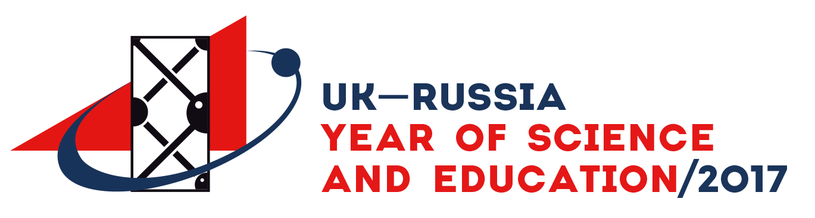

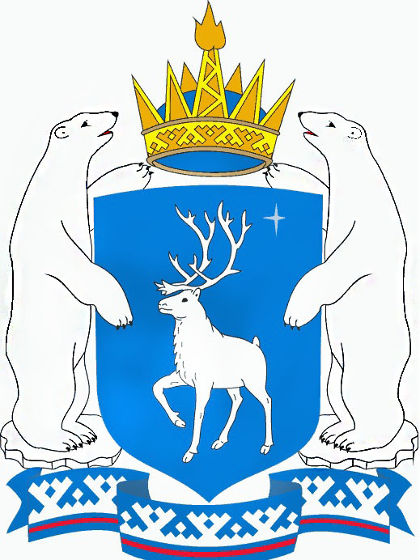  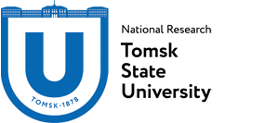      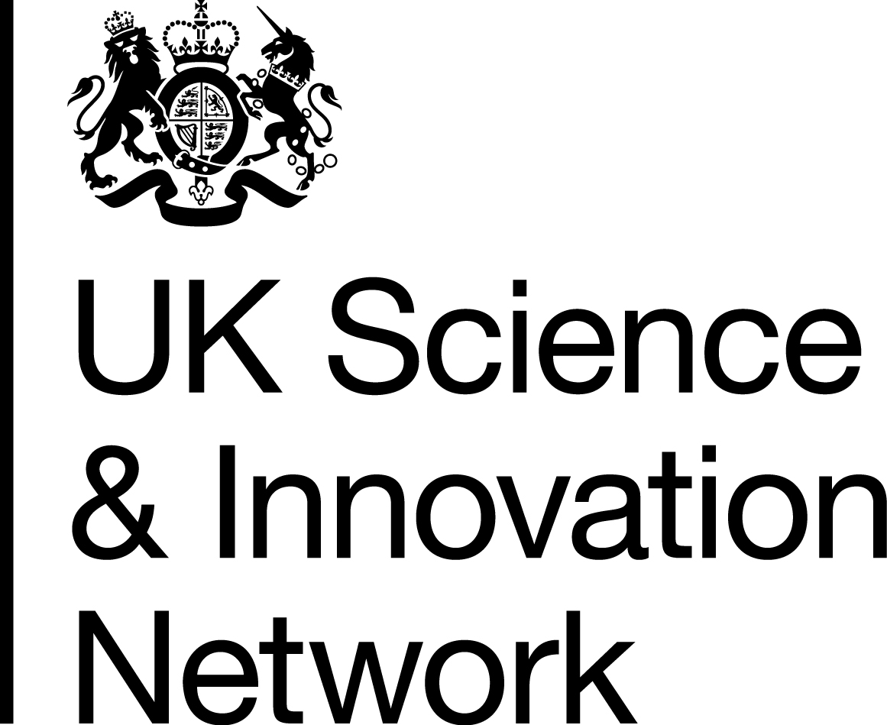  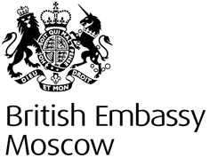 | II Siberian Environmental Change Network (SecNet)  annual international Workshop  “Siberia in a global context. Winter Weather and Climate Extremes: how can researchers, authorities and local peoples work together to record, predict and adapt?”  October 31 – November 05 2017  the city of Salekhard  Tomsk State University together with the Government of Yamal-Nenets autonomous district and with the support of UK SIN Russia and the UK Embassy in Russia holds the Second annual interdisciplinary and interactive workshop of the Siberian Environmental Change Network (SecNet).  The workshop takes place in Salekhard (YNAO) on October 31 – November 05 2017  The workshop aims  -- to bring researchers, local authorities as well as local peoples together to exchange information on extreme weather events and their impacts on the nature and society.  -- to learn, how to respond to local concerns through appropriate adaptation strategies.  Within the framework of the workshop it is planned to discuss the results of interdisciplinary scientific researches.  It is supposed that leading experts will give talks and open discussions on the partner sites of Salekhard will be organized.  Contact us: dolcezzamia@mail.ru

